Working 1

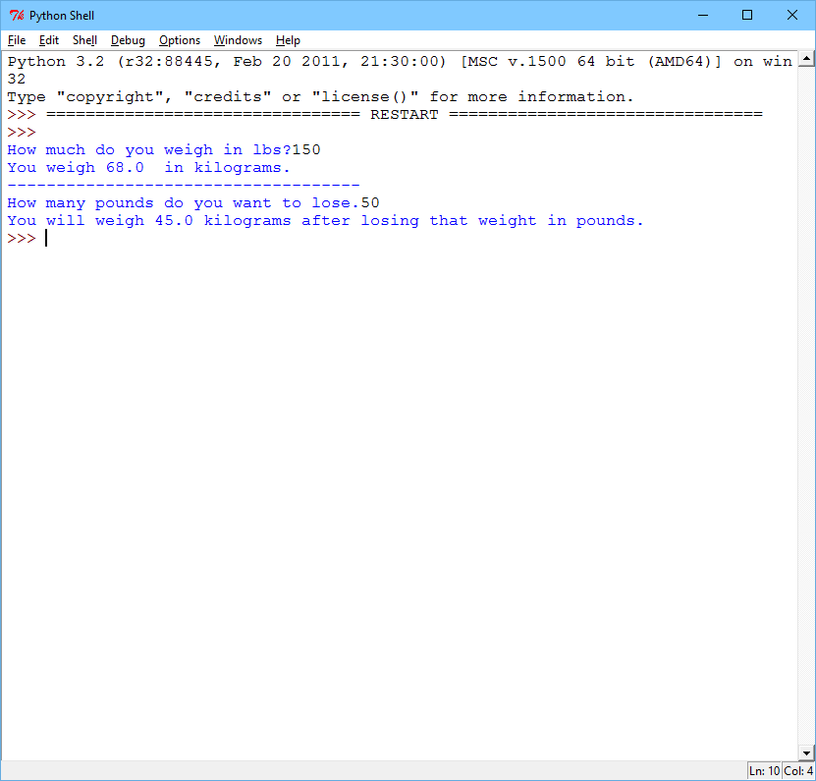

Working 2

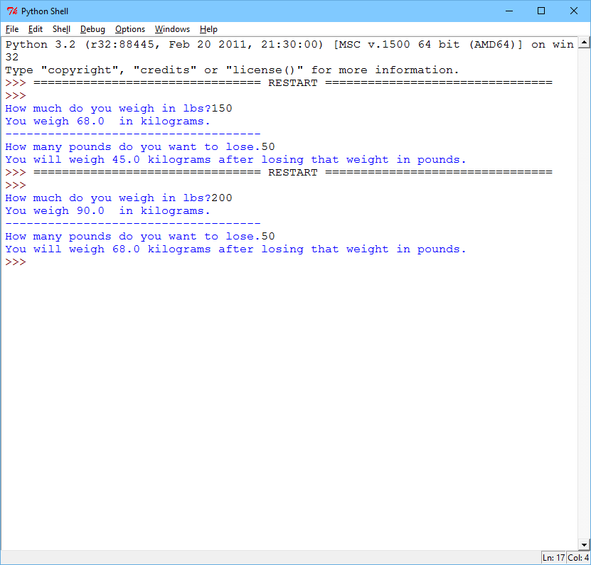

Failure 1

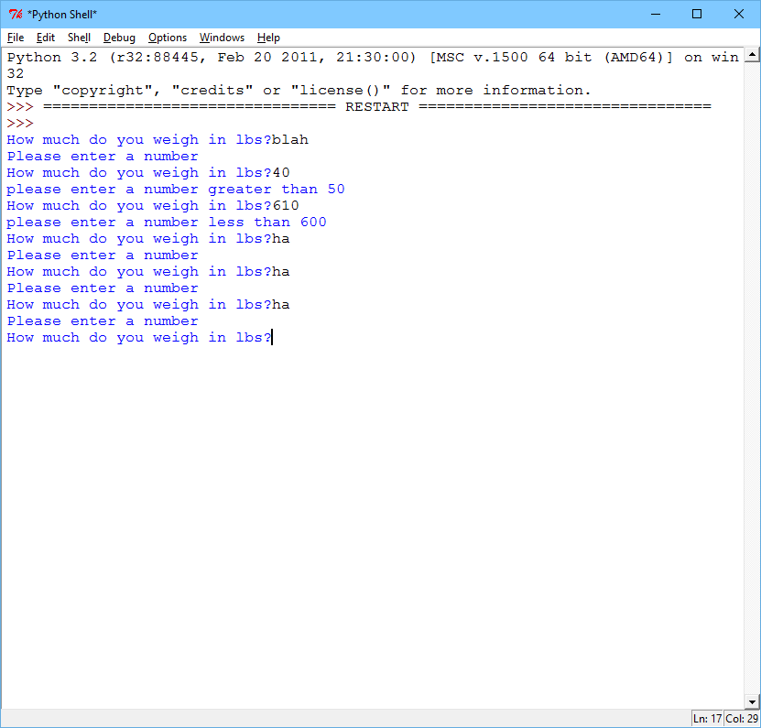

Using functions to convert to metric from pounds, then calculating your kilograms after pounds are subtracted from pounds.

# Robert Cyril Plata III  
# Weight Calculator  
# Sally Kyvernitis  
# 10/6/2015  
  
**def** calcKg**(**lbs, constant**):** # calculates the weight and formats it.  
 kg **=** lbs **\* (**1 **/** constant**)** kg **=** kg **\*** 100  
 kg **=** kg **//** 100  
 **return** kg  
  
**def** getFloat**(**prompt, low, high**):** # The function executes the prompt  
 attempts **=** 0  
 **while** attempts **<** 1**:  
 try:** # Try block for retrying  
 userInput **=** input**(**prompt**)** #asks user for input  
 userInput **=** float**(**userInput**)** #converts string to floating number  
 **if** userInput **<** low**:** print**("please enter a number greater than"**, low**)** # constant  
 attempts **=** 0  
 **if** userInput **>** high**:** print**("please enter a number less than"**, high**)** # constant  
 attempts **=** 0  
 **if** userInput **>=** low **and** userInput **<=** high**:** #if following constant rules, then it goes on  
 attempts **=** 1 #triggers the next part of the program  
 **except:** print**("Please enter a number")  
 return** userInput #returns user's input  
  
**def** getTotal**(**prompt1, weight**):** attempts **=** 0  
 **while** attempts **<** 1**:  
 try:** lose **=** input**(**prompt1**)** lose **=** float**(**lose**)** total **=** weight **-** lose  
 attempts **+=** 1  
 **except:** print**("Enter a number")  
 return** total  
  
# CONSTANTS  
LOW **=** 50  
HIGH **=** 600  
KGCONSTANT **=** 2.2046226218  
  
#Calculating KG from LBS  
getWeight **=** getFloat**("How much do you weigh in lbs?"**, LOW, HIGH**)**kg **=** calcKg**(**getWeight, KGCONSTANT**)**print**("You weigh"**,kg,**" in kilograms.")**print**("------------------------------------")**#Calculating pounds lost, then converting pound loss total to kilograms.  
calculation **=** getTotal**("How many pounds do you want to lose."**, getWeight**)**conversion **=** calcKg**(**calculation, KGCONSTANT**)**print**("You will weigh"**, conversion, **"kilograms after losing that weight in pounds.")**